13.99: a) With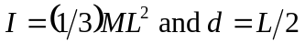 in Eq.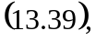 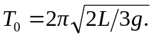 With the addedmass,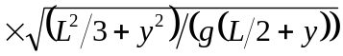 and

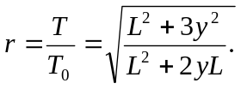

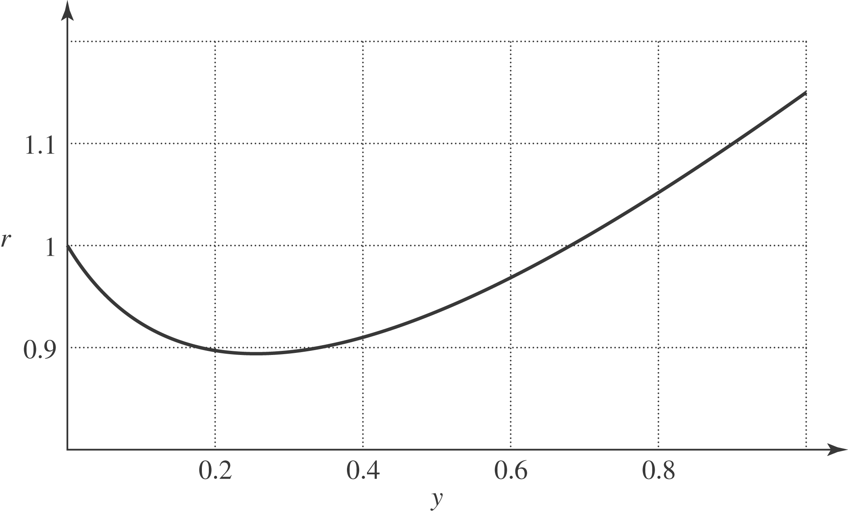

b) From the expression found in part a), 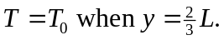 At this point, a simple pendulum with length would have the same period as the meter stick without the added mass; the two bodies oscillate with the same period and do not affect the other’s motion.

